Angelo Nolasco

July 29,2021

CPE 200L

Dr. Sarah Harris

Project Proposal

For my final project, I will make the game blackjack or also known as twenty-one, its origin in 1700 in a French casino. Some rules of the game are that it must be played with two or more players, must use a 52-card pack. The highest number of cards you can get is 11, which is the ace. With the ace, you can choose as a 1 or 11. Also, all jack, queen, and kings are tens. The objective of the game is to get twenty-one or close to twenty-one to win, if over twenty-one you lose or have the less close to twenty-one you lose. When displaying it on the DE2-115 board, I will use the 7-segment display to show player 1 and dealer total of the cards add, also player 1 bet. The first block will display a 50 in the 7-segment display which is the best, the user may double the bet. The second block diagram is the start, when the DE2-115 board turns on, player 1 and the dealer will get two random cards and add them, then display on the 7-segment display. Also, if you get an ace at the beginning, the user has to choose between 1 or 11 before allowing the user to select. The third block diagram is the input that allows the user to select stand or hit. The third block, if select stand, allows the user to stay with the amount they got. In the fourth block diagram, if the user selects the hit, the user will add another card into the total they all right they have. The user may hit as many times as they want, unless if they go over twenty-one. The users can select stands after if they are done selecting hits. The last block is the end, which is the output if player 1 wins, the green LED lights will turn on, but if player 1 loses, they don’t turn on. To see who wins it will check which player has twenty-one or is close to twenty-one, if you are over twenty-one you lose. If player 1 wins their bet will be double, or if they lose all of 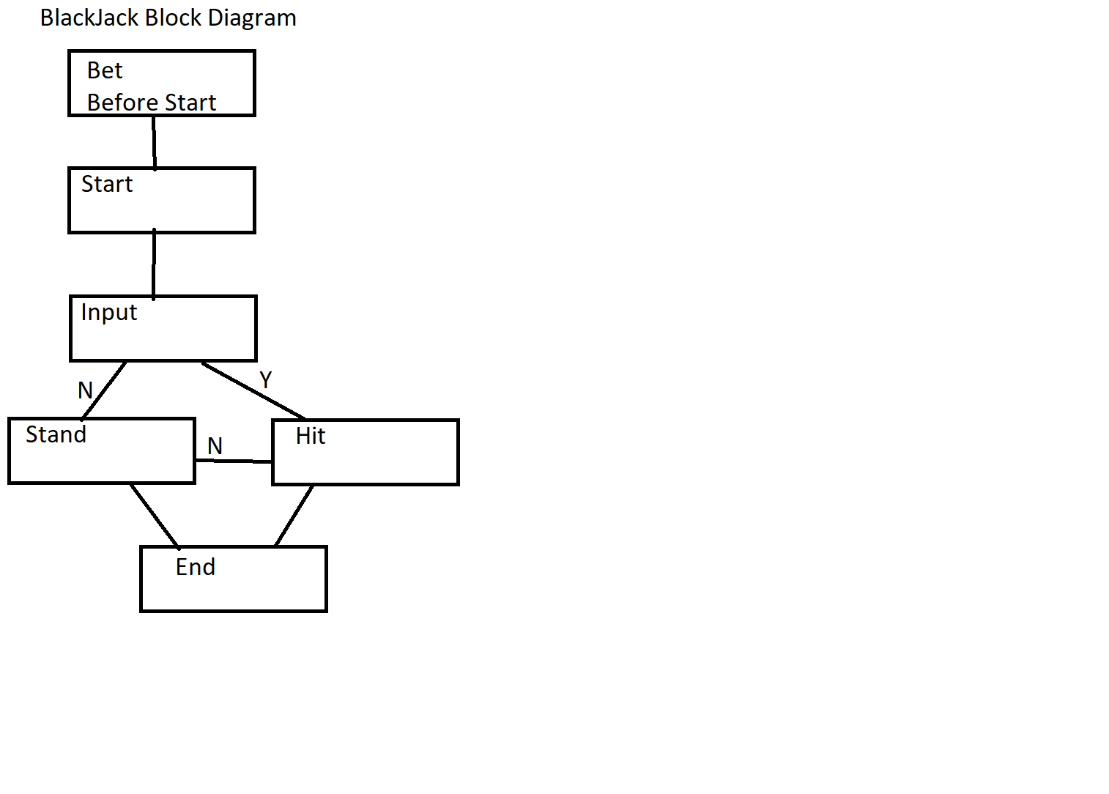their bet is lost.